**CS6301.0U1- Web Programming Languages**

**(By Amol Vaze – Net-id: - asv130130@utdallas.edu)**

**Assignment- No-3 Readme Documentation**

* **Assignment No-3** focuses on design & implementation of fully functional UTD degree course planner system for all 6 tracks given.
* My degree planner GUI web page design consists of following files which I have created under a new directory called **www21** under WAMP server (localhost).
* Link to access my local system:- **http://localhost/www21/index.php**
* User should be able to select multiple tracks in this system.
* As a part of third homework extension of homework-1&2, I have created following php files which have **HTML** code:-

1. Register.php
2. Login.php- (Showing [Initial user’s] MyProfile-page )
3. Mainform.php (Track selection while login step)
4. Logout.php
5. Degree-plan.php
6. Grade.php
7. Add-classes.php(CURD- ADD) –For Duplicate class check
8. Drop-classes.php(CURD- Drop)
9. Update-classes.php(CURD- Update)
10. Check-core.PHP
11. Classes-req.PHP
12. Coregpa.PHP
13. Credithrs.PHP
14. Transwaved.PHP
15. USE.php

A step by step explanation of the system & flow can be explained as follows with the help of each php page associated with the system flow.

* Register.php takes care of registration of new user into the system with the help of registration form provided. Necessary validation is being provided for this step.

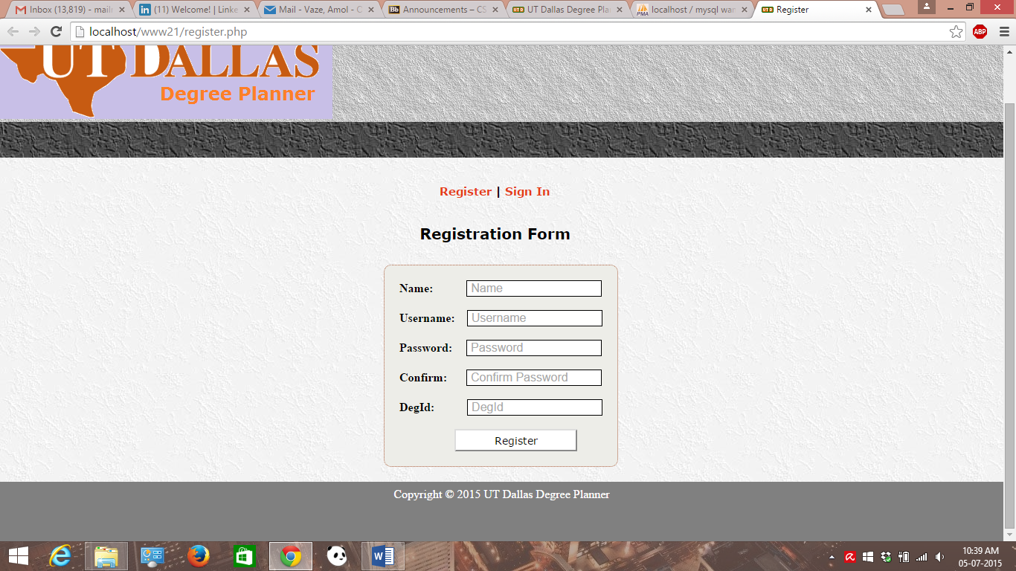

Registration form validation using JavaScript.

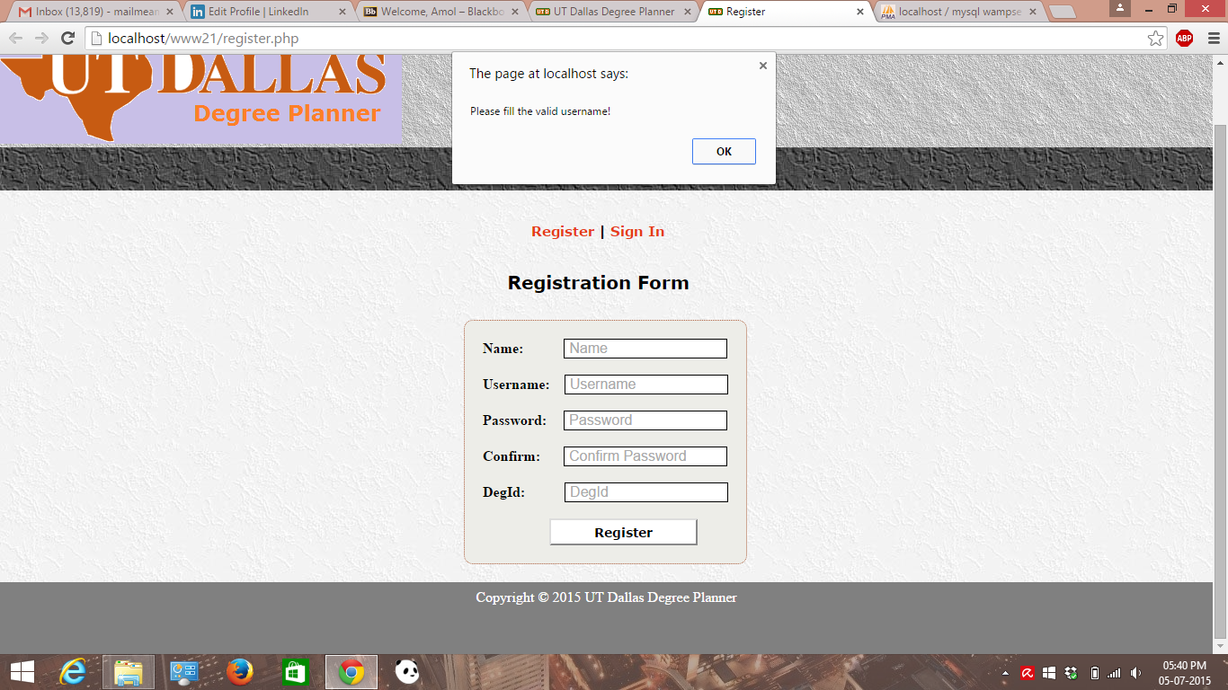

* Login.php takes care of login of the user into the system which have already been registered in to the system. Validation using JavaScript has been provided in this step.

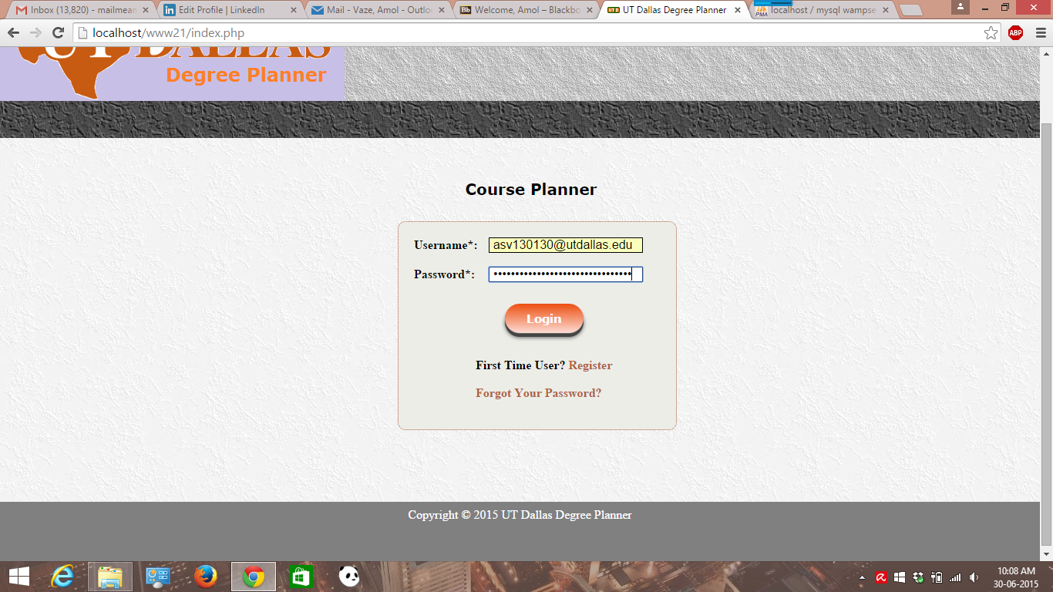

* Track selection while login of the system can be done by selecting multiple checkboxes to proceed to the profile page.

A screenshot for the same is shown below.

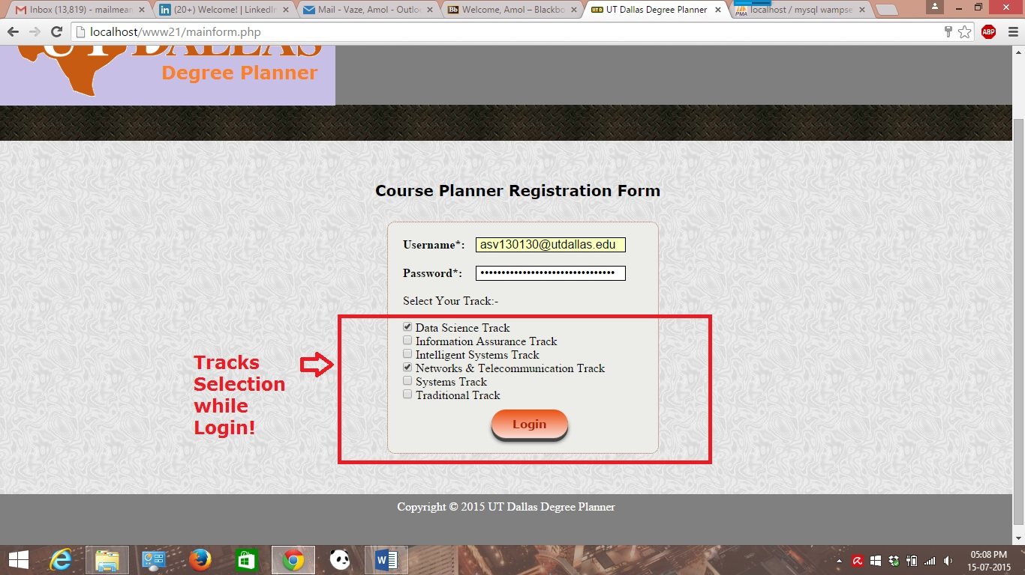

* Logout destroys user’s session and logs out user out of the system. Once successfully done, user will be redirected to the home page of the system.

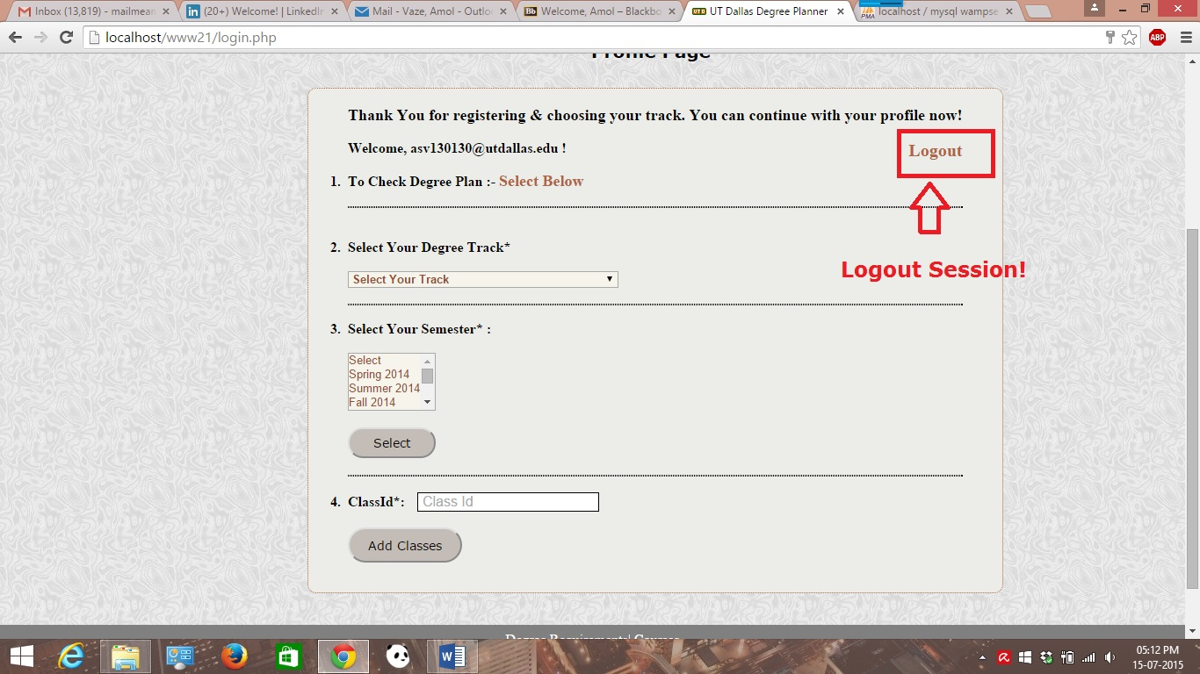

* Profile Page which is Login.php page pretty much shows user’s profile. This page gives the user to choose from multiple tracks under the drop- down menu in order to check the respective degree plan for that selected track. User must choose one track at a time to view degree plan. Once selected from drop down list, user will be taken to the corresponding track page.

A screenshot for (updated) profile page & drop down menu for select track can be shown below:-

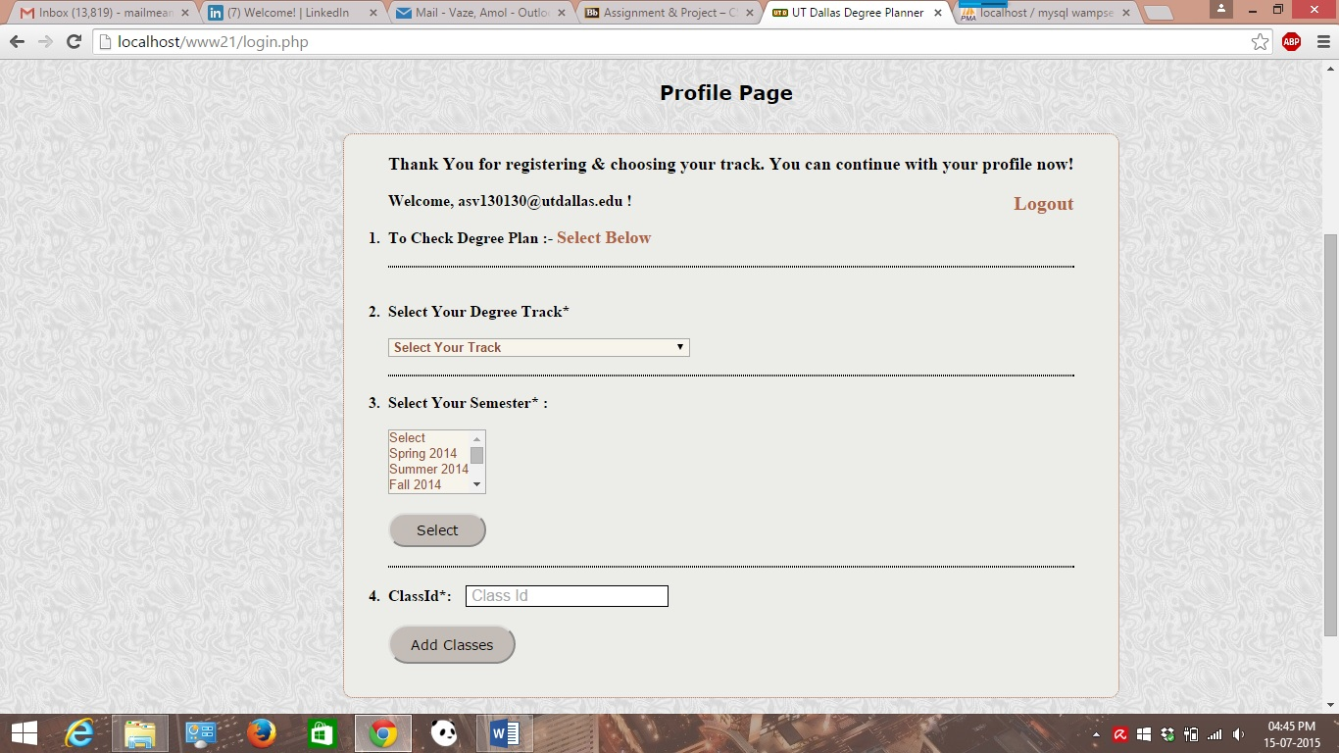

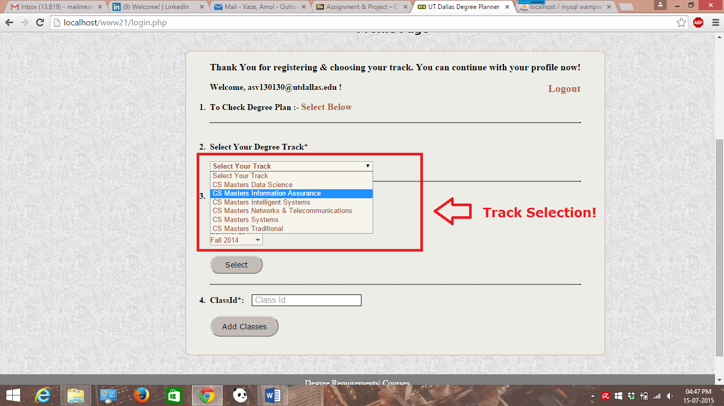

* For adding new classes, user should enter class-id to proceed. Screenshot is attached.

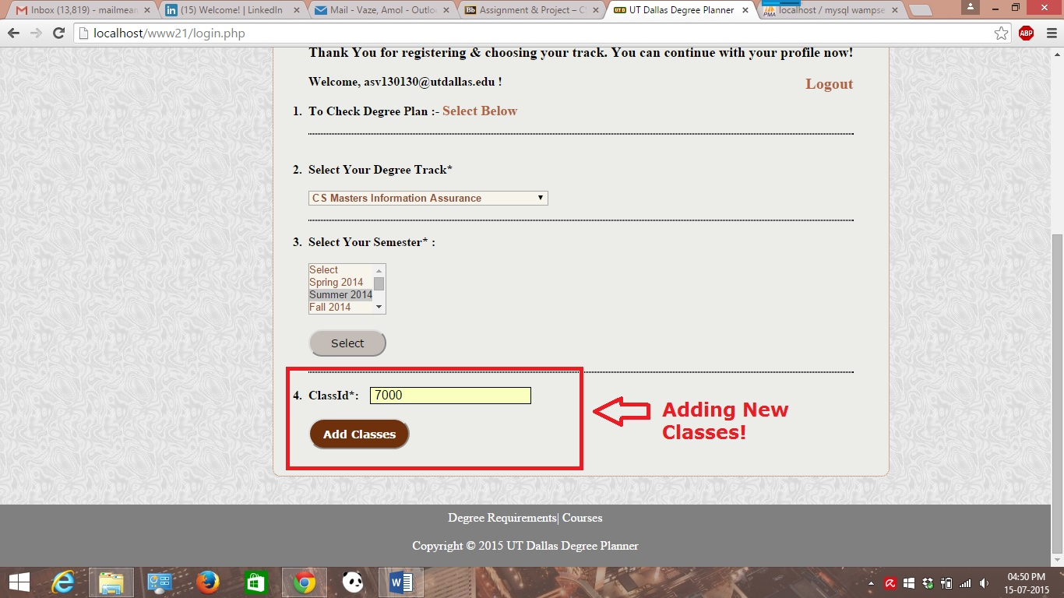

Thus, after user has pressed this button, user will be taken to the add-classes form. With this form, user should be able to add/drop/update class to and from the database.

In this form, duplicate classes’ case has been handled by add-classes.php itself. A screenshot is attached for both add-class form and duplicate class.

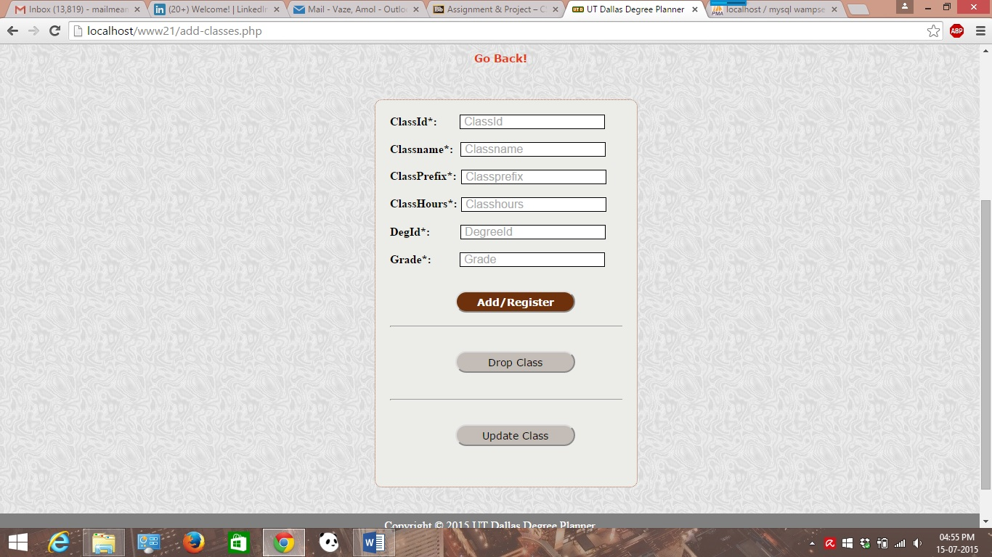

A screenshot for duplicate class handling is shown below. It won’t allow user to enter the class details if already exists in the database. If tried, system gives the pop up alert message showing class id already exists.

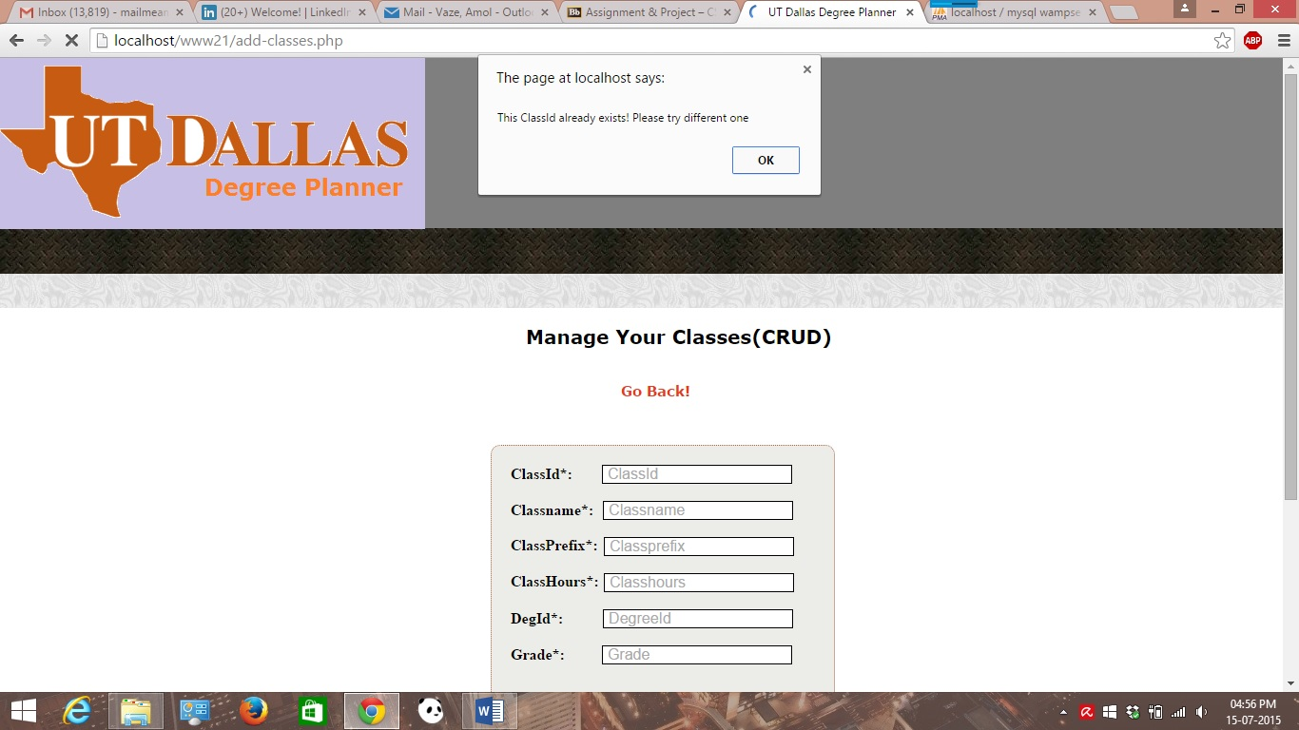

* After track selection on the profile page, user will be taken to the corresponding degree plan page(degree-plan.php for example in case of Data Science track or respective php files attached during the submission). A screenshot is shown below for one of the tracks.

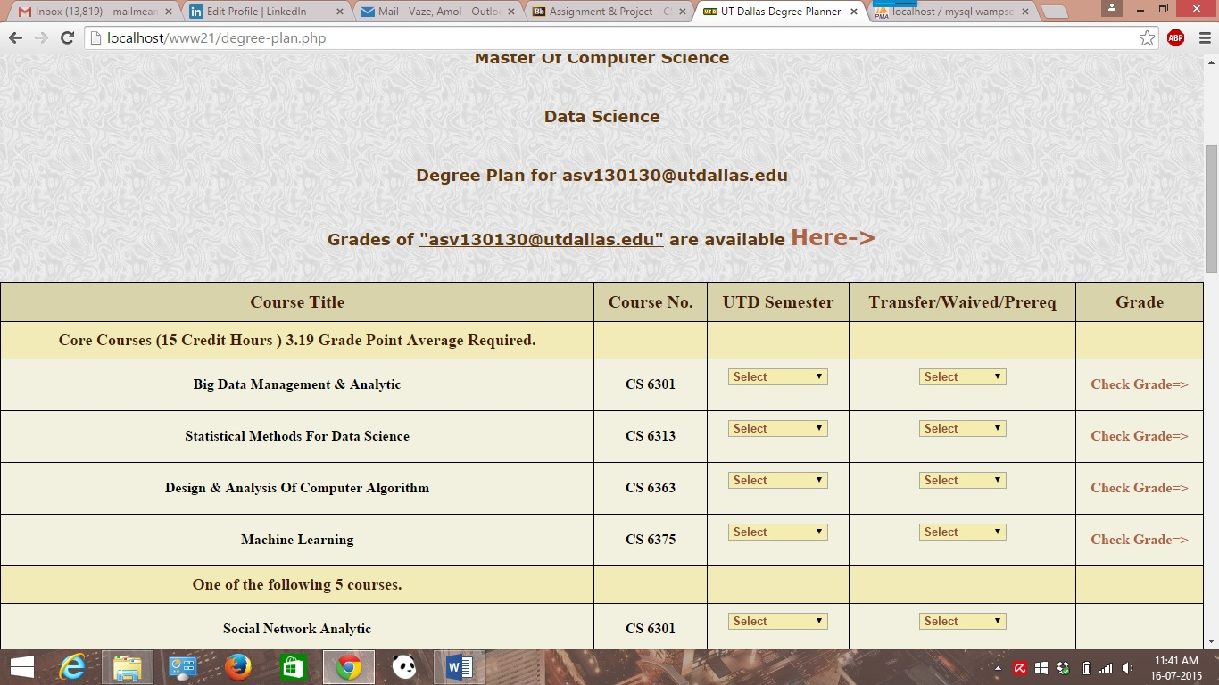

* Core course requirement is checked on this page(called check-core.php in this case), so that the system prompts the user by displaying message if user has not completed core courses requirement for a particular track. A screenshot for one of the track’s core course requirement is shown.

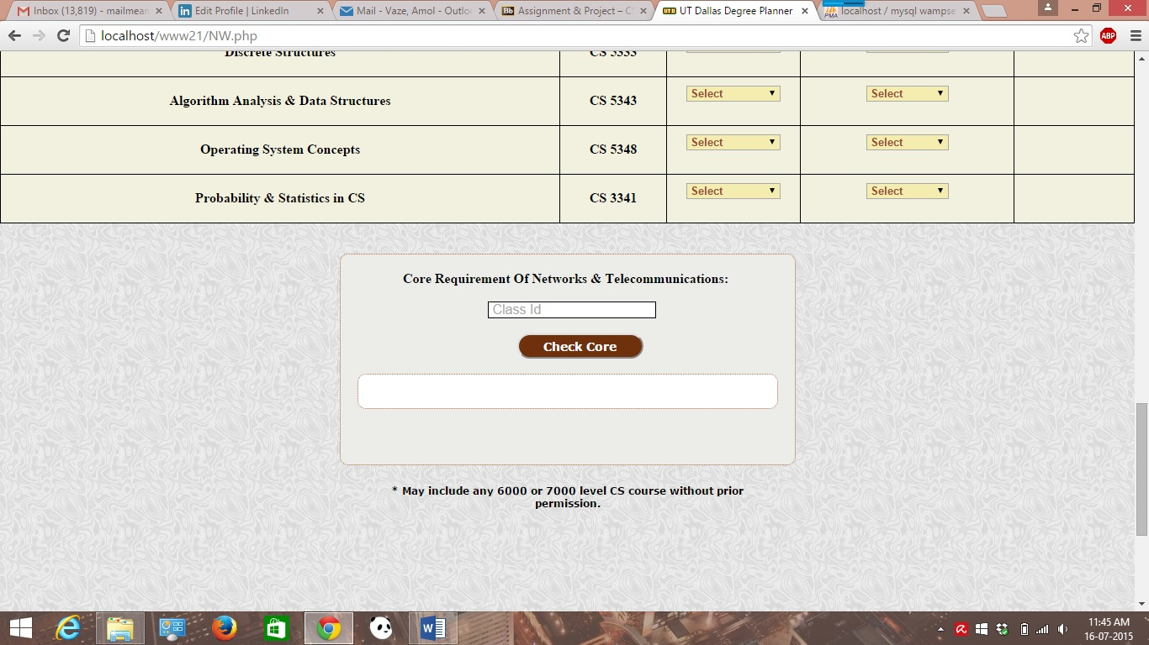

* A screenshot for system’s prompt when user is yet to finish core need is shown.

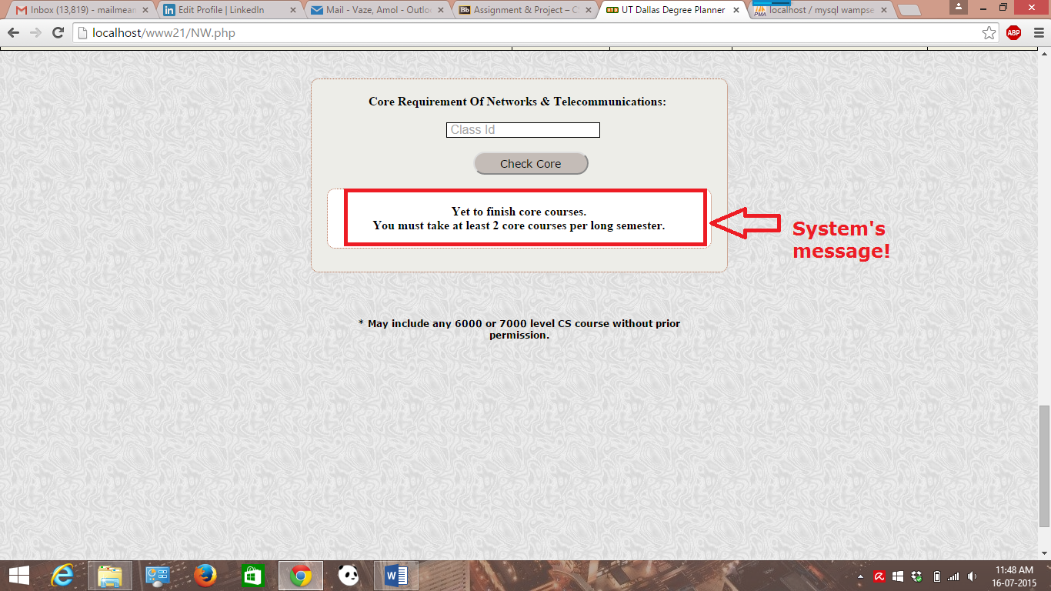

* In order to take care of transfer/waived and prerequisite courses of the user, system has separate column and drop down list on the degree plan page. Once user has selected one of the options from the drop down list, user will be redirected to the page where user should be able to see the same. A php file used for this purpose are classes-req.php & transwaved.php respectively.

A screenshot for prerequisite /transfer/waived is shown.

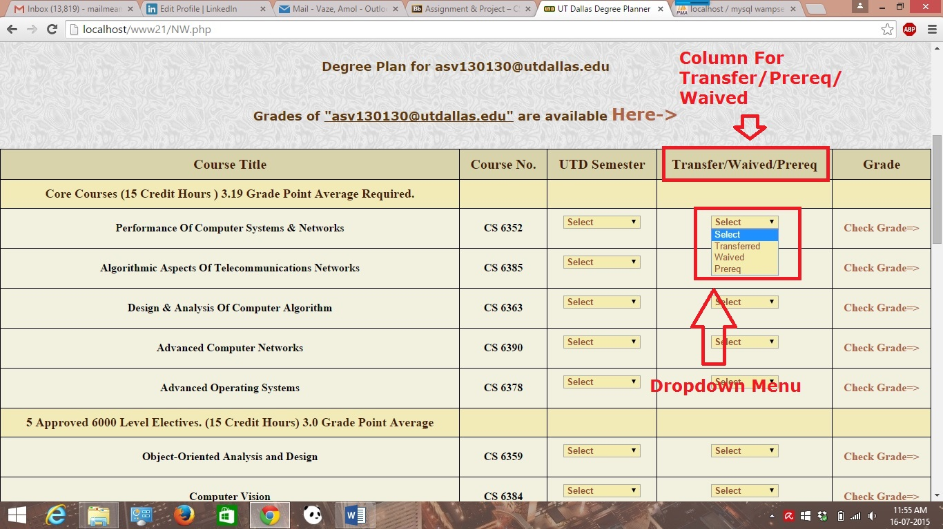

* User should be able to check grades on the link shown in the screenshot. Once clicked, user will be taken to the page where the page shows the grades for the courses taken. A php files used for this is grades.php

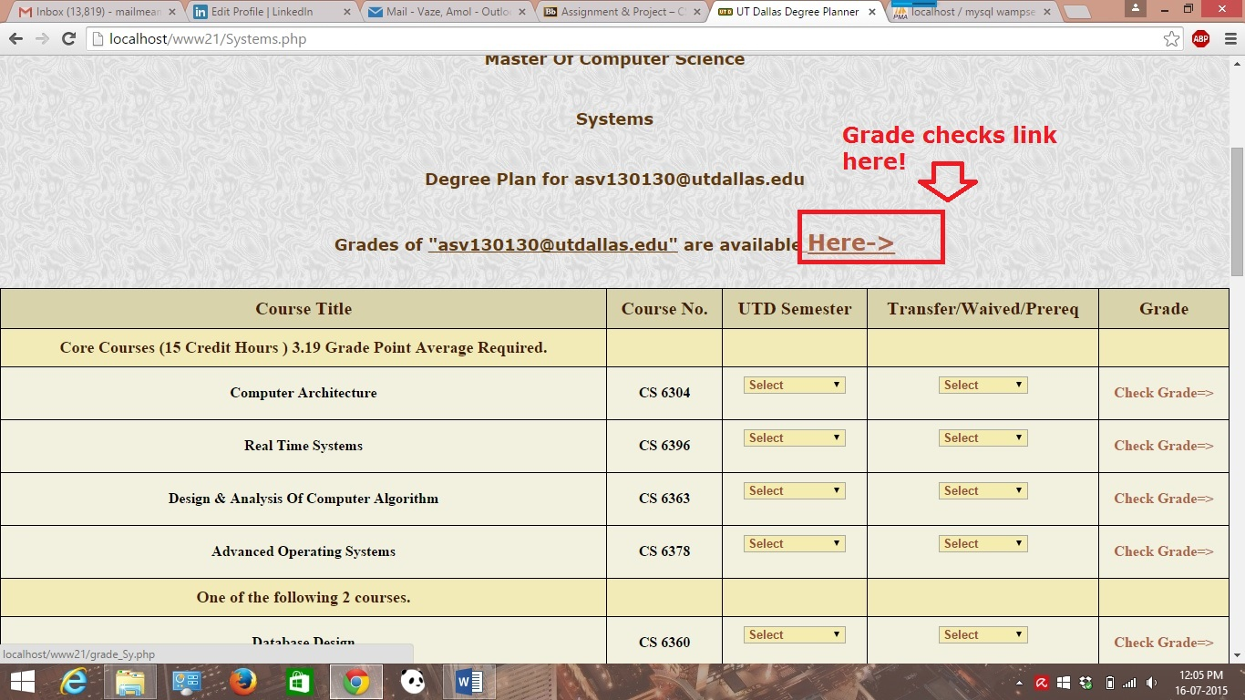

* A grade analysis page is shown in the screenshot. On this page, user should be able to see the grades for the courses taken & this page shows the detailed grades/ GPA analysis of the grades for a particular track chosen.
* It includes information like no of credit hours completed, transfer/ prereq & core/overall GPA of the courses taken by the user. Also, depending upon the core/overall GPA of the user, system displays the corresponding message to the user.

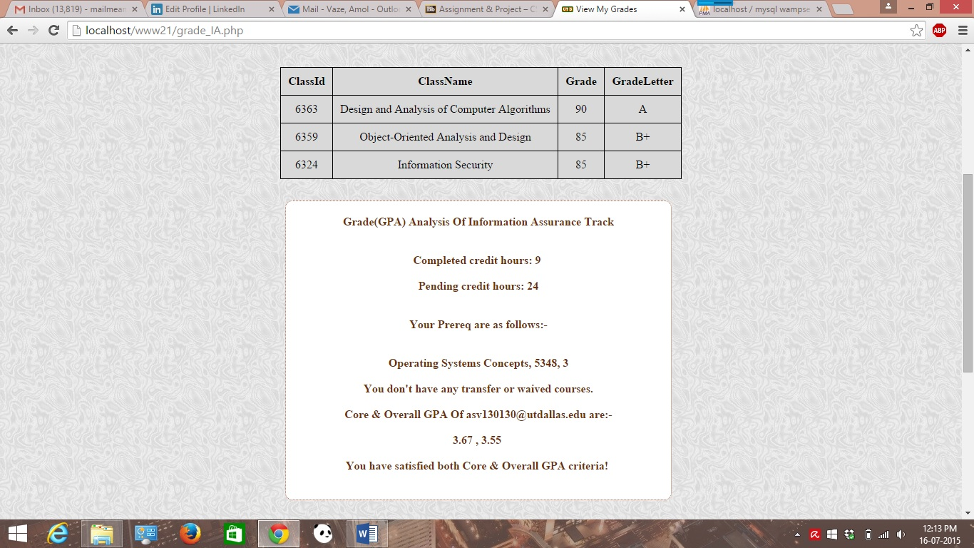

* Student is graduating in more than one tracks. An example screen shot is attached where it shows student has fulfilled the GPA criteria for both **Data Science track & Intelligent Systems** track respectively.
* A grade analysis web page for IS track has details showing status.

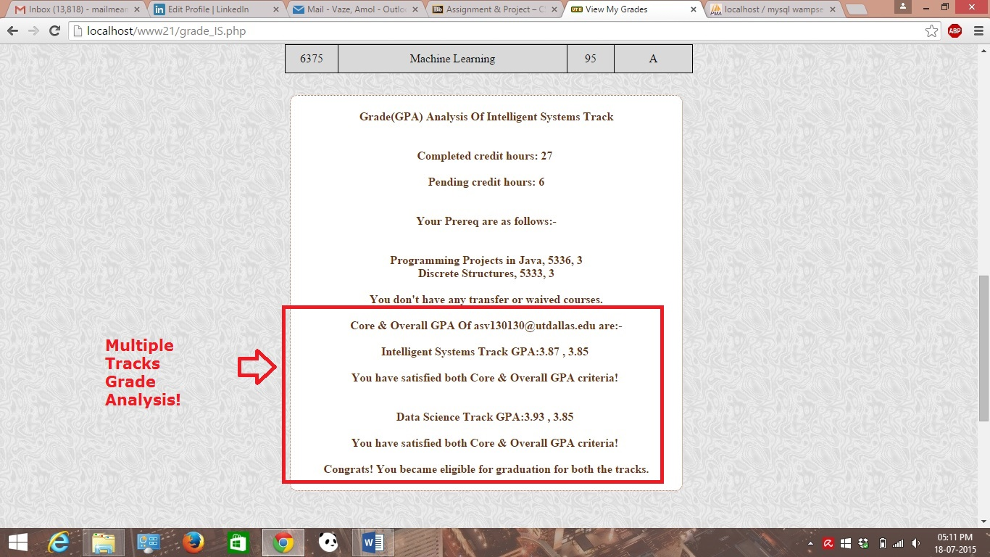

Another User Case with screenshot explained.

* Consider an example let say another user has logged into the system with login credentials, then new user should be able to view profile separately. A screenshot is attached below.

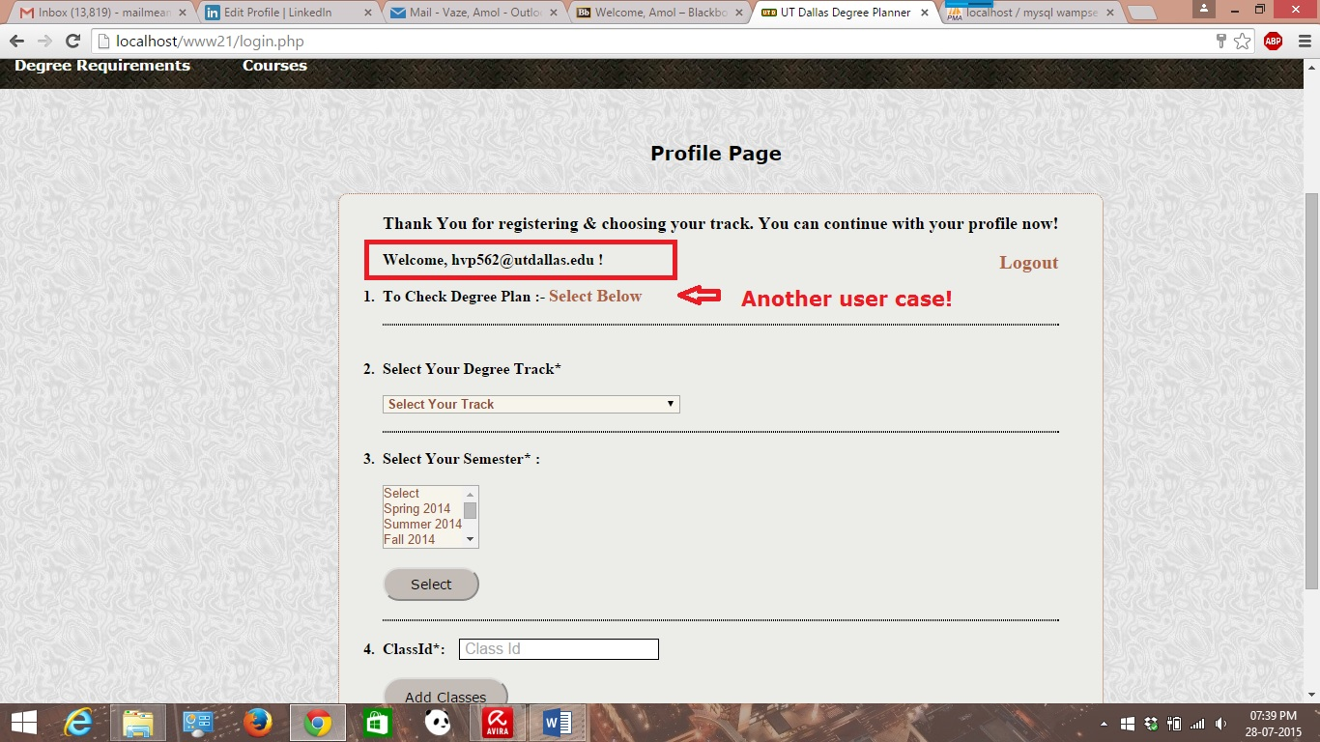

* Now a newly logged in user should be able to view tracks from the drop down. For example, consider a scenario here where this user belongs to Network track & hence user will choose networks & telecom track from the menu.

A Screenshot illustrating this is shown below:-

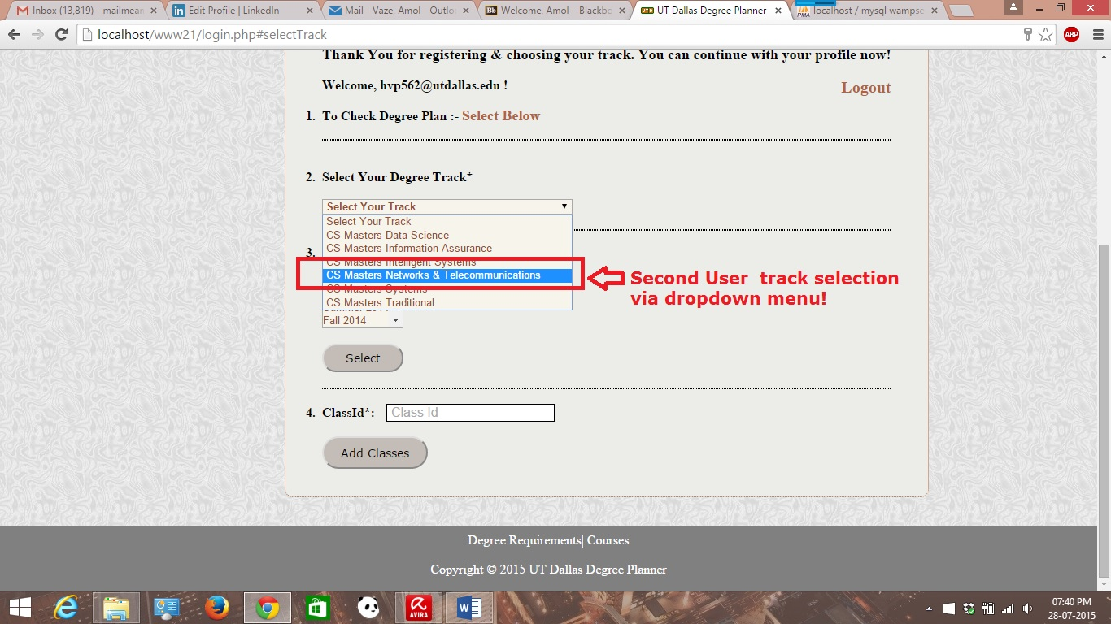

* A newly logged in user should be able to see the degree plan of interest. With regards to this current example under consideration, a logged in user is viewing Network & Telecommunications degree plan.

A screenshot is attached below.

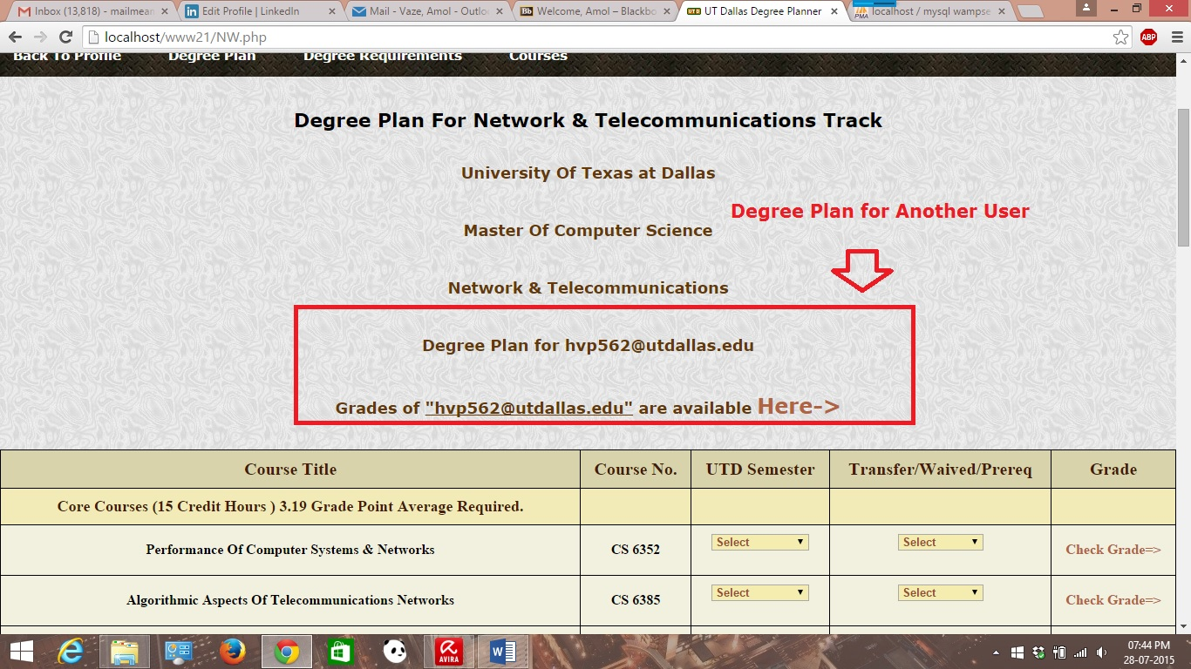

* Also, a newly logged in user should be able to view the grades for the track chosen. For example, in this case, grades for the current core and elective courses of Networks tracks with their corresponding grades have been shown.

A screenshot of view grades of Networks & Telecommunications track is shown below.

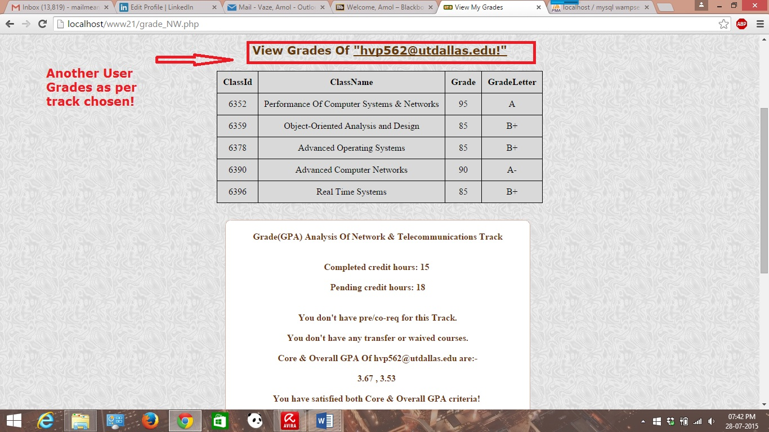

Test Plans & Test cases with screenshots (Done with Selenium Tool- Automated Tests):-

* Test case- Login page & its validation- screenshot attached.

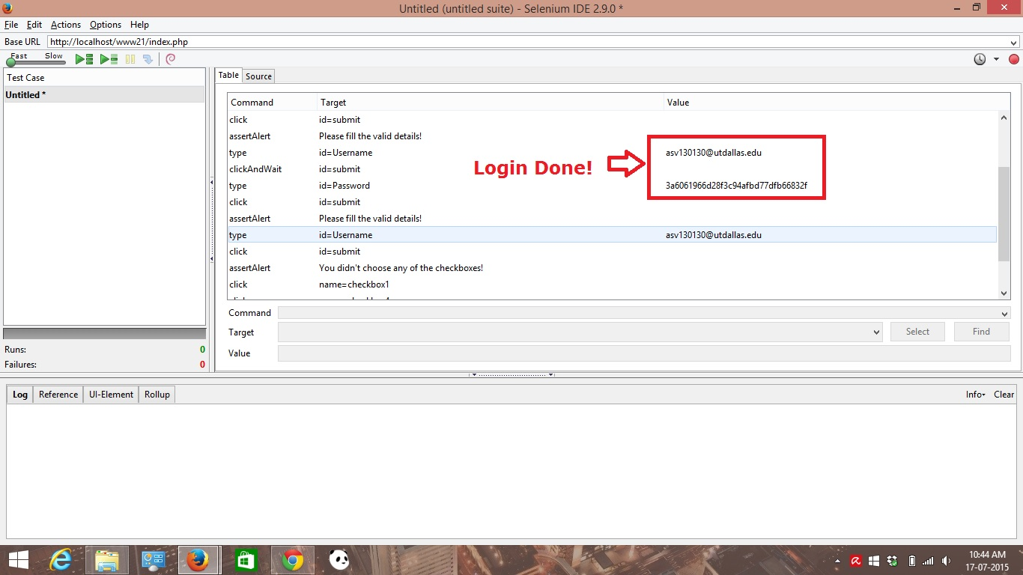

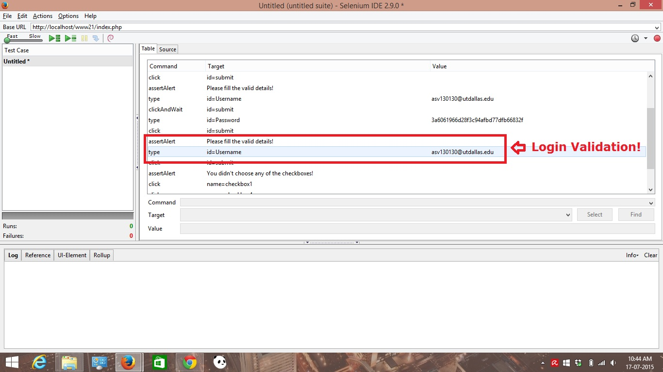

* Test case for checkbox validation while choosing track during login

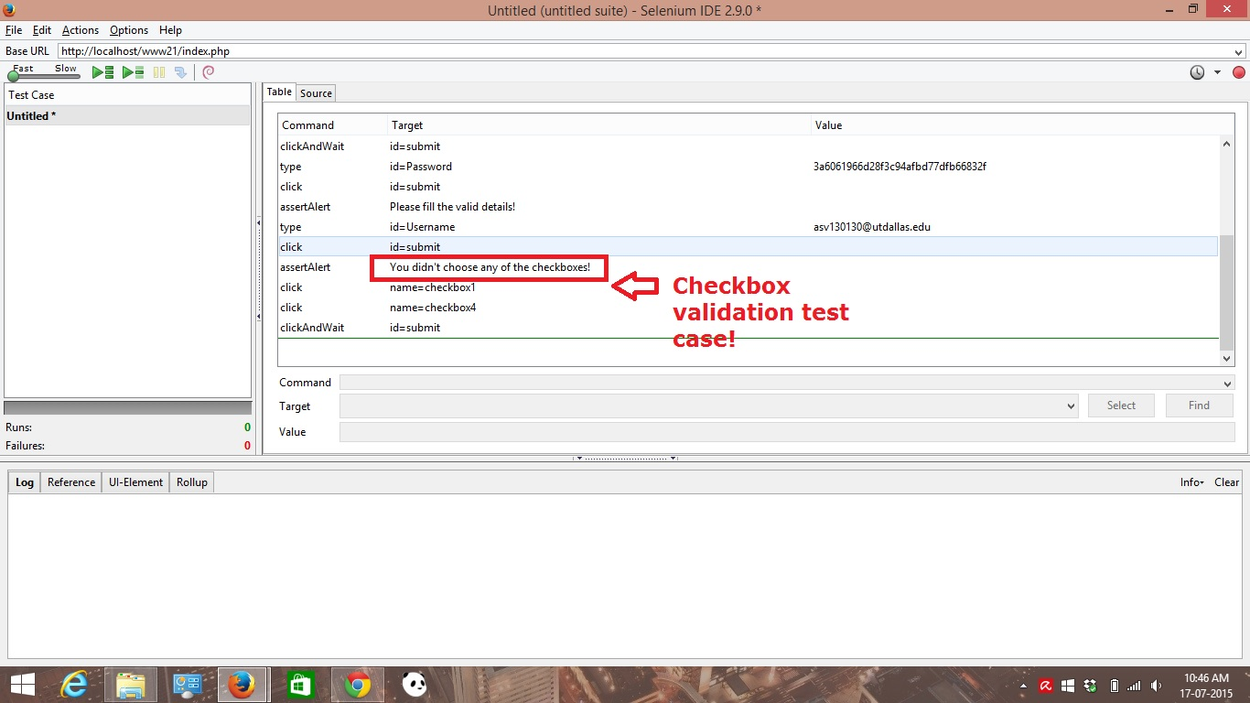

* Add classes form Test case for duplicate class checking – screenshot is attached

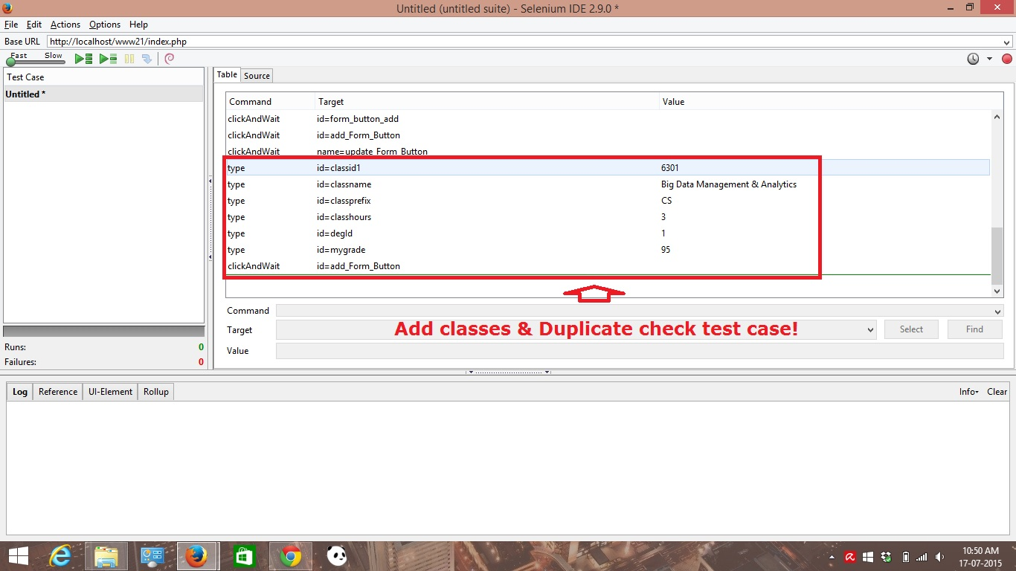

* System Logout test case- screenshot is attached.

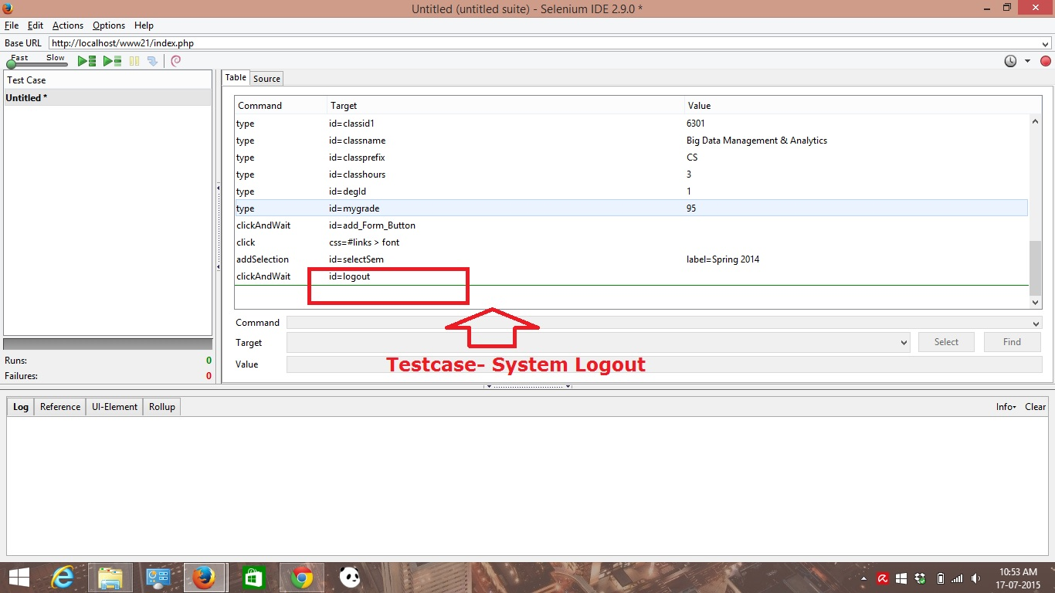

Degree Plan corresponding test cases and test plans have been conducted; screenshots of which are attached.

* Test case/ test plan for navigation and track selection for viewing degree plan

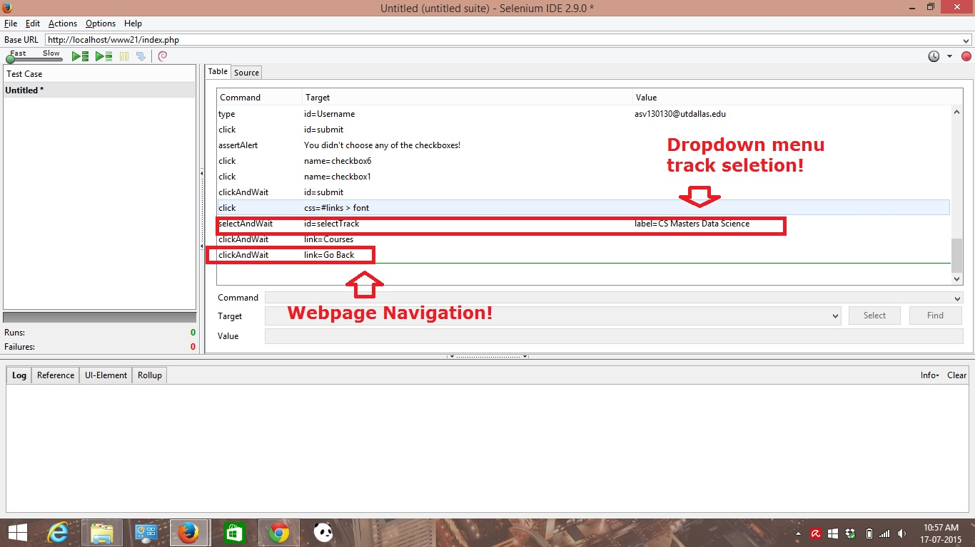

* Test case/test plan for core class requirement check on degree plan web page.

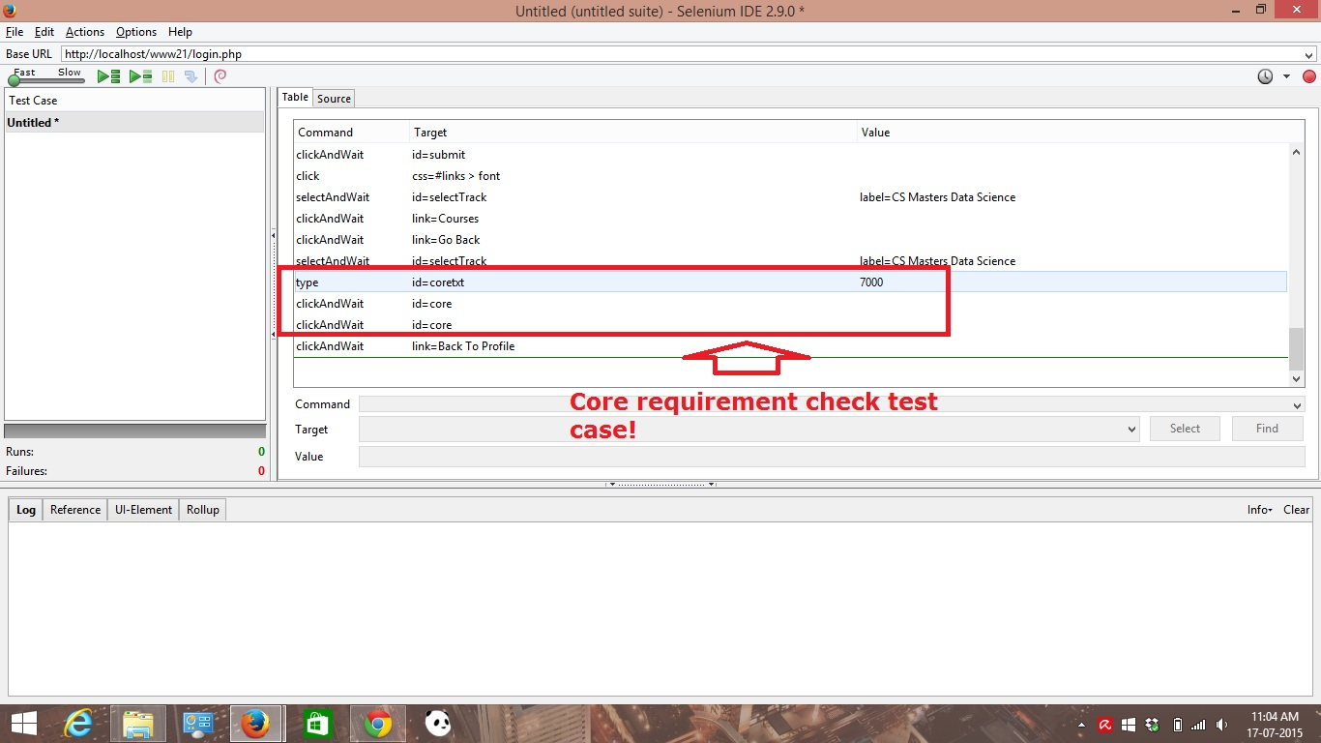

* Test case/ test plan for transfer & prerequisite courses on the degree plan web page.

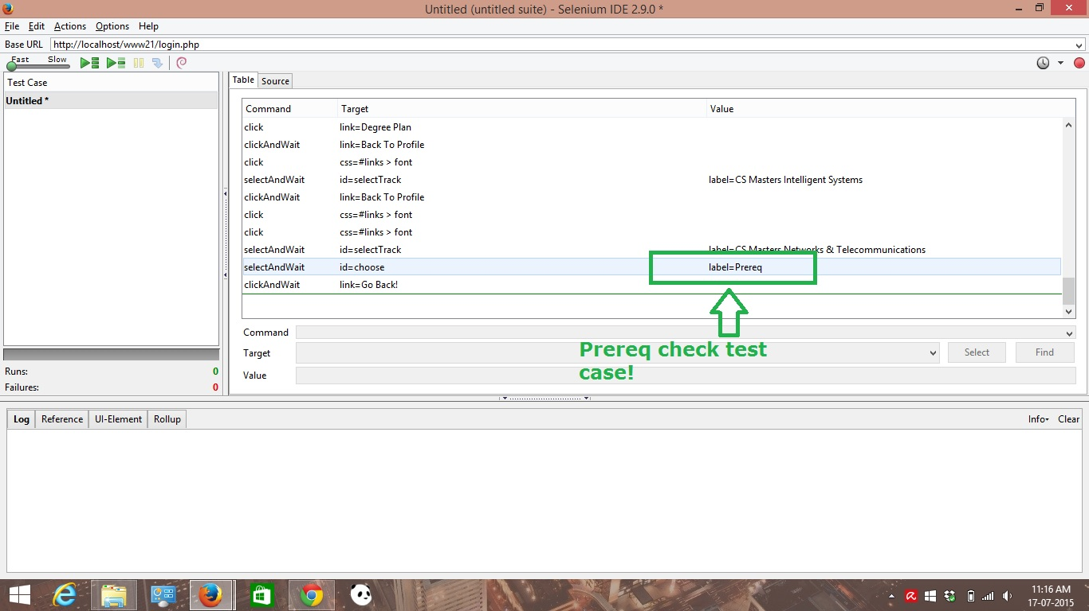

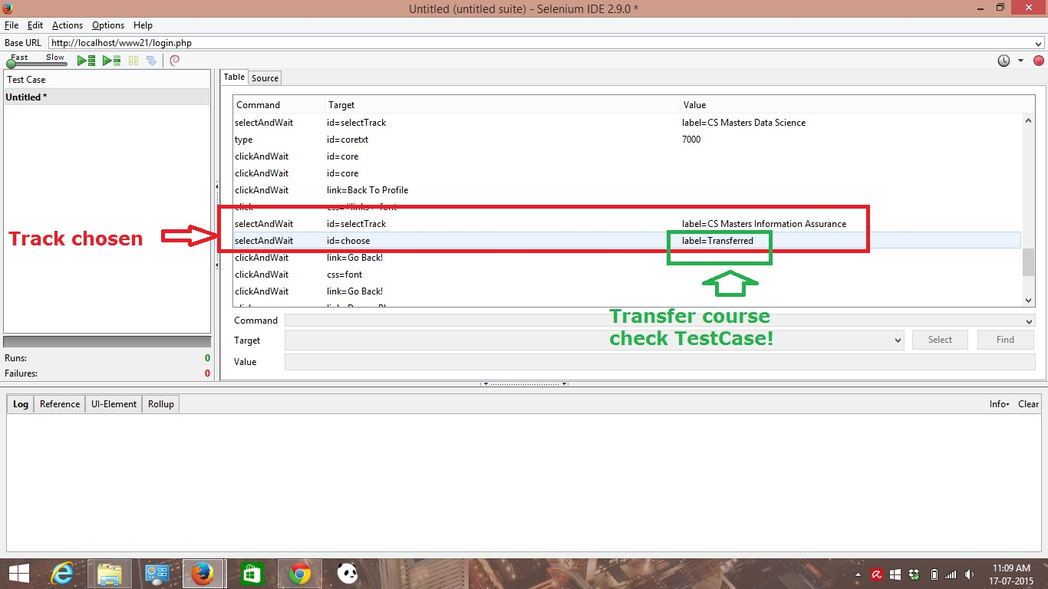

* Test case/ test plan for checking grades on the degree plan page.

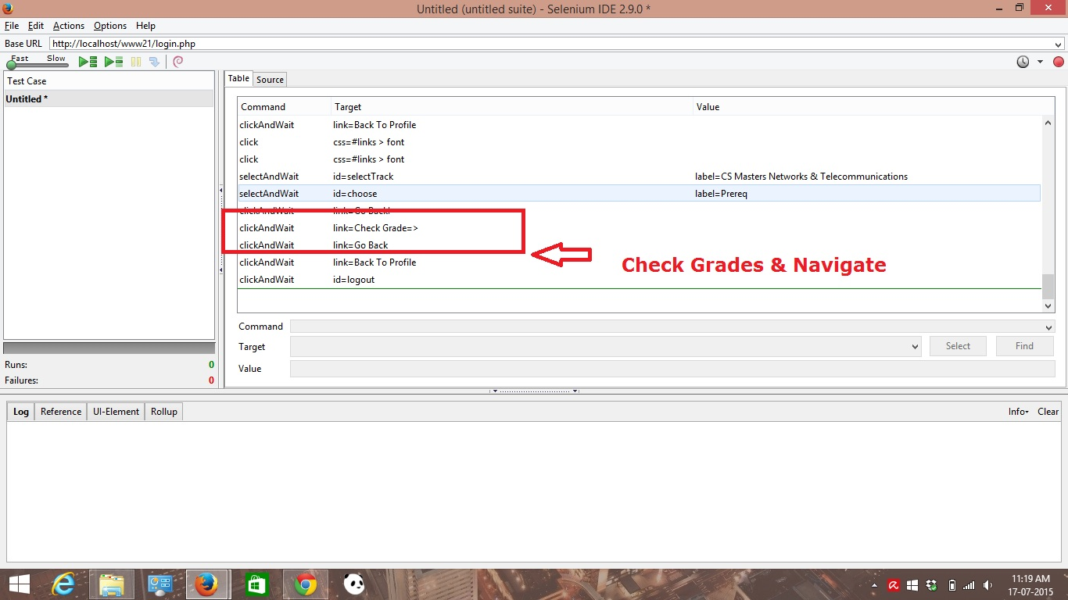

**Database Tables**

**Class Table**:

CREATE TABLE IF NOT EXISTS `class` (

`ClassId` int(11) NOT NULL,

`ClassName` varchar(100) DEFAULT NULL,

`ClassPrfx` char(4) DEFAULT NULL,

`ClassHours` int(11) DEFAULT NULL,

`DegId` smallint(6) DEFAULT NULL,

`Grade` smallint(6) DEFAULT NULL,

PRIMARY KEY (`ClassId`),

KEY `DegId` (`DegId`)

) ENGINE=InnoDB DEFAULT CHARSET=latin1;

**Course Table:**

CREATE TABLE IF NOT EXISTS `courses` (

`id` int(11) NOT NULL AUTO_INCREMENT,

`number` varchar(255) COLLATE utf8_unicode_ci DEFAULT NULL,

`prefix` varchar(255) COLLATE utf8_unicode_ci DEFAULT NULL,

`name` varchar(255) COLLATE utf8_unicode_ci DEFAULT NULL,

`description` text COLLATE utf8_unicode_ci,

`created_at` datetime NOT NULL,

`updated_at` datetime NOT NULL,

PRIMARY KEY (`id`)

) ENGINE=InnoDB DEFAULT CHARSET=utf8 COLLATE=utf8_unicode_ci AUTO_INCREMENT=73 ;

**Degree Plan Table**

CREATE TABLE IF NOT EXISTS `degreeplan` (

`DegId` smallint(6) NOT NULL AUTO_INCREMENT,

`DegName` varchar(50) DEFAULT NULL,

`DeptId` smallint(6) DEFAULT NULL,

PRIMARY KEY (`DegId`),

KEY `DeptId` (`DeptId`)

) ENGINE=InnoDB DEFAULT CHARSET=latin1 AUTO_INCREMENT=7 ;

Department Table

CREATE TABLE IF NOT EXISTS `department` (

`DeptId` smallint(6) NOT NULL AUTO_INCREMENT,

`DeptName` varchar(50) DEFAULT NULL,

`DeptInit` char(4) DEFAULT NULL,

PRIMARY KEY (`DeptId`)

) ENGINE=InnoDB DEFAULT CHARSET=latin1 AUTO_INCREMENT=5 ;

**Grade Table**

CREATE TABLE IF NOT EXISTS `grade` (

`GradeId` smallint(6) NOT NULL AUTO_INCREMENT,

`ClassId` int(11) DEFAULT NULL,

`UserId` smallint(6) DEFAULT NULL,

`Passed` bit(1) DEFAULT NULL,

`Grade` decimal(18,2) DEFAULT NULL,

`GpaWeight` decimal(18,2) DEFAULT NULL,

`GradeLetter` varchar(16) NOT NULL,

PRIMARY KEY (`GradeId`),

KEY `ClassId` (`ClassId`),

KEY `UserId` (`UserId`)

) ENGINE=InnoDB DEFAULT CHARSET=latin1 AUTO_INCREMENT=18 ;

**Transwaved Table**

CREATE TABLE IF NOT EXISTS `transferwaved` (

`ClassId` int(11) NOT NULL,

`ClassName` varchar(100) DEFAULT NULL,

`ClassPrfx` char(4) DEFAULT NULL,

`ClassHours` int(11) DEFAULT NULL,

`DegId` smallint(6) DEFAULT NULL,

`UserId` smallint(6) DEFAULT NULL,

`Transfered` varchar(15) DEFAULT NULL,

`Waived` varchar(15) DEFAULT NULL,

PRIMARY KEY (`ClassId`),

KEY `UserId` (`UserId`)

) ENGINE=InnoDB DEFAULT CHARSET=latin1;

**Conclusion:-**

Thus, this is a thorough documentation for fully functional degree planner system implemented for all the tracks of CS Masters. It also covers the design, implementation and testing for fully functional working system under consideration.

[**Please Note**: - A comprehensive design document with requirement & specification or use-case has been attached separately as per question. Also, the JavaScript & Ajax files required by the code are submitted.]